UCGSA Brief on Graduate Program Administrators (GPAs) and IT Services for the Alberta New Democratic Party

Background

In 2019, the University of Calgary [announced](https://calgaryherald.com/news/local-news/layoffs-begin-at-u-of-c-mount-royal-following-provincial-budget-cuts) that 250 support staff positions would be eliminated due to provincial budget cuts. These staff cuts included cuts to the University’s Information Technologies (IT) team and Graduate Program Administrators (GPAs).

The role of IT in a large organization is self-explanatory. GPAs, however, perform an essential yet underappreciated role for the University, faculty, and graduate students. These are non-academic staff members who organize department-sponsored events, provide advice to students on course enrollment, manage scholarship applications, ensure immigration documentation is up-to-date and properly filed for international students, schedule thesis/dissertation defense and organize the defense committees, and serve as a touchpoint for Faculty Deans to learn about the administrative challenges graduate students are facing.

Before the onset of massive budget cuts, each department had their own GPA. This allowed graduate students to have easy access to administrative support; typically, this also ensured that graduate students and GPAs could learn enough about one another to tailor the support offered to each student’s individual, personalized needs.

*After* the onset of the budget cuts, GPAs have been reorganized into a “POD system.” Under the new system, GPAs are shared between multiple departments. Due to privacy concerns, we will avoid naming any particular support staff members; however, we are aware of a single GPA managing as many as five separate departments.

Concerns

The lack of support for IT staff has negatively impacted UCalgary operations, including teaching, research, and the various services offered on campus. For instance, a lack of IT support has led to multiple wifi outages, which as [this](https://www.reddit.com/r/UCalgary/comments/1i7jq74/wifi_down_again/) r/UCalgary subreddit post notes, has happened with enough frequency that students are considering protests and letter-writing campaigns.

A lack of IT support also leaves UCalgary vulnerable to cybersecurity threats. The Cybersecurity team is separate from the frontline IT services staff, and there is currently no indication that the Cybersecurity team has suffered the same level of staffing cuts as IT. However, IT staff serve as an important first step in ensuring cybersecurity protocols are followed, such as ensuring that UCalgary property is updated, that students and faculty are aware of good cybersecurity practices, and protecting UCalgary websites from hacking attempts or other malicious behaviour.

In regards to GPAs, the POD system did not reduce the number of responsibilities that support staff have. Instead, it multiplied existing responsibilities by requiring GPAs to do the same work for multiple departments. This has led to concerns of overwork and exhaustion for GPAs. From a graduate student perspective, it has also led to delayed paperwork—including very sensitive paperwork, like immigration forms. We would like to emphasize that UCGSA, under no circumstances, holds GPAs responsible for these delays. The consensus amongst graduate students is that this was an inevitable outcome of expecting current GPAs to do the same amount of work that, pre-2019, would have been done by four or five individuals.

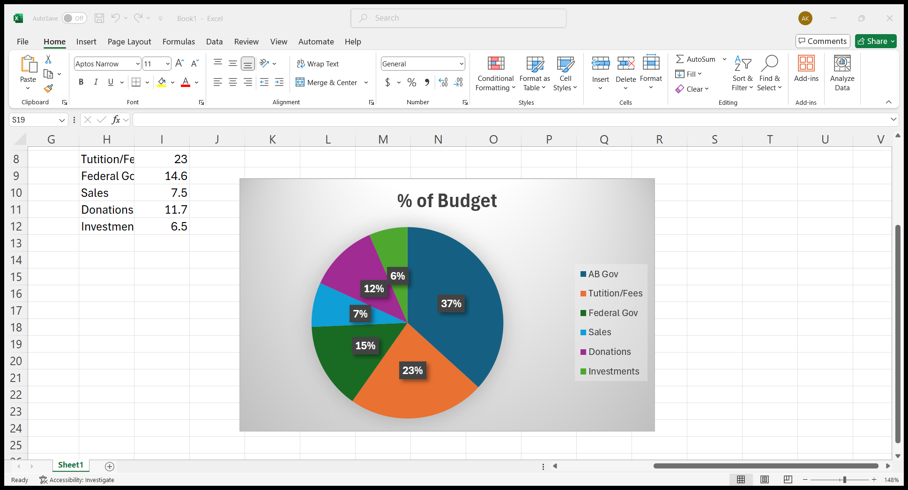Paperwork delays will also cost UCalgary money, even if a lack of support staff ostensibly shows up as “low overhead costs” in the university’s budget. This is because graduate students are expected, as part of our participation in scholarship competitions, to bring external revenue into the university. [Current regulations](https://grad.ucalgary.ca/awards/policies-and-regulations/regulations) from the Faculty of Graduate students strongly encourage graduate students to apply for all possible sources of external funding, especially those from the Tri-Council granting agencies (NSERC, SSHRC, and CIHR). Most universities in Canada then “claw back” some of your funding—either by reducing your non-scholarship stipend or by taking some portion of the value of your scholarship—for other operational purposes, a process somewhat outlined in this [forum post](https://forum.thegradcafe.com/topic/44015-claw-backs/) from 2013. External grant funding, especially from the federal government, represents a substantial portion of the UCalgary operating budget: [14.6% of UCalgary’s revenue](https://www.ucalgary.ca/finance/sites/default/files/teams/5/fr-2024-financial-statement.pdf) came from direct contributions from Ottawa, which is overwhelmingly research funding to faculty and graduate students. If those scholarship applications are delayed due to support staff being overworked, or simply lost in the filing process, then this could be costing the university a substantial amount of money.

Possible Solutions

The easiest solution to the thin support infrastructure UCalgary has would be to increase operating funding. Operating funding grants can do towards any learning or research activity the university engages in, including providing technical and administrative support for faculties and departments. This is in contrast with targeted enrollment expansion funding, which is narrowly focused on creating more seats for students, but often misses the administrative costs associated with program creation.

Alternatively, and especially from a graduate student perspective, we could see increased support for “indirect costs of research.” Indirect costs are the legal, administrative, utility, and facility costs necessary to successfully approve, conduct, and review a research project. For example, the legal and immigration services required to ensure an archeologist has permission to visit a Mayan excavation cite in Mexico—and that said archeologist is properly insured against any risks associated with conducting field work—would count as indirect costs of research.

Currently, Canada covers [significantly less](https://www.uvic.ca/research-services/assets/docs/Grants/indirectcor/AUCCReportInstCostsResearch2009.pdf) indirect research costs that other nations, like the United States and United Kingdom. Multiple reports—including a 2013 report from FINA, the Naylor Report, and a 2022 SRSR report—all called for greater indirect cost support for research projects. If governments were willing to support more indirect research costs, this could include IT services essential for research—such as better WiFi infrastructure and staff support—and GPAs, given the essential role they play in scholarship applications.

Summary

Support staff is essential for a well-functioning university, and budget cuts have trimmed enough of the support infrastructure away that UCalgary may be actively losing money. If nothing else, the university—and graduate students—are more vulnerable to things like misfiled immigration paperwork, loss of scholarship opportunities, or cybersecurity threats, than we were before the onset of the 2019 budget cuts. This means that any restoration of funding must include money earmarked for administrative support staff, whether by increasing operating funding (rather than just targeted enrollment) or through expanding the amount of funding available for indirect costs of research.