UCGSA Brief on Fair Dealing
August 18th, 2026
Background:
Section 29 of the Copyright Act exempts work that is being used for research, private study, education, parody, or satire from charges of copyright infringement. Educational institutions—i.e., schools and post-secondary institutions—can reproduce otherwise copyrighted work under fair dealing so long as they satisfy Section 29.4(3), which requires that the work being reproduced to not be commercially available. The exact definition of “fair” is defined by judicial precedent rather than in the Copyright Act itself.
Under Canadian jurisprudence, the initial burden of proof is on the plaintiff to show that a violation of their copyright has occurred, followed by the defendant having to prove their use of copyrighted material is allowable under fair dealing. Courts will look at factors like how much of a work was reproduced, how widely distributed it was, if it’s in the public interest to distribute the work, the impact on the original work’s commercial viability, and whether there were alternative means of accessing this work that would have fulfilled the same academic purpose. If all of these are fulfilled, then the courts will rule that no copyright infringement occurred. In order to limit costly litigation, most post-secondary institutions have their own guidelines on fair dealing that stay close to established judicial precedent. For example, the University of Calgary’s fair dealing guidelines state that only 10% of a copyrighted work can be freely reproduced, to avoid an “unfair” amount of copyrighted material to be distributed.
There are no conclusive studies on the savings post-secondary institutions received from fair dealing, but past licensing agreements have been costly. For example, there was a licensing agreement between Universities Canada (then known as the Association of Universities and Colleges Canada) and Access Copyright, which cost institutions $26 per full-time equivalent student. For an institution with 30,000 FTEs, that would equate to $780,000 a year. These costs were passed on to students in the form of tuition increases, especially as provincial and federal funding for higher education declined. Alternatively, as university budgets began to tighten, certain licenses were dropped from libraries, depriving student researchers of access to cutting edge journals and datasets.
Concerns:
Graduate students rarely use textbooks. Most of our learning materials are journal articles or monographs. As such, the most effective way to keep the cost of learning materials down for our members is to make journals and monographs affordable. Fair dealing helps accomplish this by allowing course instructors to reproduce portions of otherwise copyrighted work for educational purposes, ensuring graduate students either don’t have to pay for class materials (either as learners or as course instructors).
In 2023, the Copyright Act was due for review, and the Canadian publishing industry launched a campaign to strike fair dealing from Canadian law. Prominent authors, such as Marget Attwood—a longtime critic of fair dealing—argued that fair dealing was tantamount of “robbery” and was directly responsible for declining incomes for Canadian authors. While the review was completed without fair dealing being struck from Canadian law, the rise of generative A.I. has renewed the focus on copyright and artist’s revenue, with authors and publishers suing A.I. companies to recoup lost income.
As Michael Geist, one of the leading experts on digital and copyright law in Canada, has noted, the claims that fair dealing allow educational institutions to illegally reproduce copyright material on mass is a fabrication, especially when these institutions still have to pay large sums for licensing complete works. The claim that fair dealing erodes authors income is also suspect. First, most graduate student course materials are journal articles, and authors receive no income from publishing an academic article; the profits accrue entirely with the publisher and publisher alone. And secondly, as already stated, most institutions have strict limits on the amount of copyrighted material that can be freely republished. It’s hard to see how reproducing a single chapter from a novel will negatively impact the author’s sales, unless the author believes that only one chapter is needed to fully experience their story. This also neglects the fact that prominent Canadian authors like Peter Watts and Cory Doctorow, who license their books under Creative Commons and thus have their novels available for free on their website, believe that free access in fact “saved their careers.” Finally, science requires information to be open and accessible. An overzealous application of copyright can lead to an “anti-commons” situation where socially beneficial research and discussion are stymied.
Any campaign to strike fair dealing from Canadian law will cost graduate students greatly with little benefit to Canadian authors (some of which, it must be remembered, are graduate students as well). This is especially true in the case of journal articles, where publisher profits are essentially rents extracted from expensive licensing agreements (see Figure 1 below).
Figure 1.
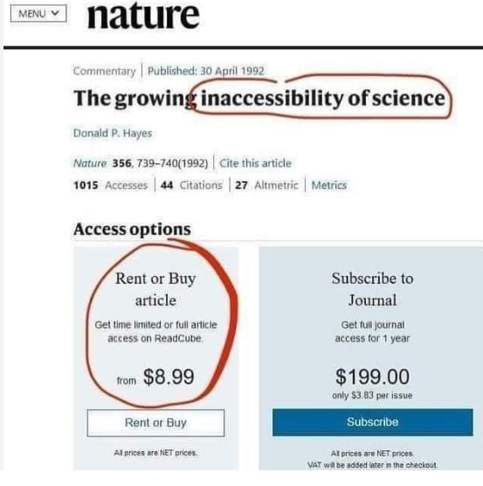

https://laws-lois.justice.gc.ca/eng/acts/c-42/page-6.html
CCH Canadian Ltd. v. Law Society of Upper Canada, [2004] 1 S.C.R. 339.
https://www.lib.sfu.ca/help/academic-integrity/copyright/fair-dealing
https://library.ucalgary.ca/services/copyright/fair-dealing
https://www.cbc.ca/news/canada/universities-square-off-against-copyright-group-1.1392240
https://theconversation.com/copyright-exceptions-in-canadian-education-arent-a-loophole-theyre-essential-207559
https://excesscopyright.blogspot.com/2011/03/to-margaret-atwood-copyright-and-cars.html
https://www.cbc.ca/news/entertainment/authors-open-letter-ai-companies-1.6910352
https://www.michaelgeist.ca/2024/12/canadianmediaopenai/
https://www.michaelgeist.ca/2023/09/countering-copyright-misinformation-canadian-libraries-speak-out-against-ongoing-campaign-to-undermine-user-rights/
https://whenihavetime.com/2009/04/06/interview-with-cory-doctorow-part-1-copyfight-and-creative-commons/
https://www.reddit.com/r/IAmA/comments/2enwks/iama_science_fiction_author_named_peter_watts_i/
https://scholarship.law.columbia.edu/cgi/viewcontent.cgi?article=2779&context=faculty_scholarship

