University of Calgary Graduate Students’ Association

1030 ES, 844 Campus Place NW Calgary, Alberta T2N 1N4

Tel (403) 220-5997 Fax (403)282-8992

[www.gsa.ucalgary.ca](http://www.gsa.ucalgary.ca)

## Leadership Award Terms of Reference 2023 – 2024 Academic Year

Intake Period: January 29 – February 9, 2024

Intake Deadline: **February 9, 2024** **4:00 PM MT**

Submit applications online

Applications and/or letter of reference received outside of the intake period will **NOT** be evaluated. Late applications will **NOT** be evaluated. Incomplete applications (unanswered questions or additional information) will **NOT** be evaluated. It is the sole responsibility of the applicant to ensure completeness of the application.

This document and application link are available on the GSA’s [website](https://gsa.ucalgary.ca/financial-support/awards/).

Questions regarding this application should be directed to the GSA Awards Committee Chair or Vice Chair at [awards.gsa@ucalgary.ca](mailto:awards.gsa@ucalgary.ca)

*This information is collected following the standards set by the Personal Information and Privacy Act (PIPA). It is required to determine your eligibility for the award and may be used for research and statistical analysis. If you have any questions about the collection or use of this information, please contact the Awards Committee Chair at* awards.gsa@ucalgary.ca.



## Purpose

This award was established by the Graduate Students’ Association of the University of Calgary in recognition of graduate students who have demonstrated outstanding leadership in the University of Calgary graduate student community, and whose work has impacted the University of Calgary graduate student body.

## Value

One (1) $5,000 CDN award.

## Eligibility

To be eligible for this award:

1. Applicants must be **more than 18 months** into their graduate degree at the University of Calgary. Students within 18 months of their first graduate degree at the University of Calgary should apply for the Emerging Leadership Award.
2. Applicants must not have received this award previously during any degree at the University of Calgary.
3. Applicant must be an active member of the GSA as defined by Section 4, sub- section 4.2 of the GSA Bylaws during the 2023/2024 academic year; and
4. Applicant must be in **Good Standing** with the GSA
5. Applicant must be in **Good Academic Standing** with the University of Calgary

## Documents Required

The following documents are required to apply for this award:

1. Most recent University of Calgary transcript;

o A recent unofficial transcript (less than a month old from the date of application) is acceptable. For information on how to download the most recent unofficial transcript, please see **Supplemental Information** at the end of this document.

1. Admission letter to the University of Calgary (access through UofC student portal - see images below) that includes the program **start date**;
2. A CV highlighting leadership and volunteer contributions
3. A statement outlining contributions to the University of Calgary community and especially the graduate student community **since the start of your graduate program**. This statement must describe the impact the applicant’s leadership work has had on the University of Calgary community and specifically the graduate student body. *The personal statement in the online application must not exceed 800 words.*
4. **Two reference letters** supporting the applicant’s leadership experience and involvement in the University of Calgary community and specifically the graduate student body.
5. **Incomplete applications (missing information, extra information/documents and incorrectly filled out) or applications received after the intake deadline will NOT be considered.**

## Submission Requirements

When applying for this award, the following process must be followed:

1. Completed applications MUST be submitted using the [online awards portal](https://gsa.ucalgary.ca/financial-support/awards/);
2. Applications MUST be written and signed in **English**;
3. Reference letters MUST:
4. Be from Graduate Supervisor/Volunteer Supervisor/Manager/Team lead etc.
5. Be received by the application deadline.
6. *Focus on your leadership and volunteer contributions since the start of your program (specifically service to the University of Calgary community and especially the graduate student community*). This may need to be stressed if you are using a professor who is used to writing you academic reference letters. Ensure your reference knows that this application is a leadership award.
7. Applications MUST be submitted with a **University of Calgary email address**;
8. **Incomplete applications (missing information, extra information/documents and incorrectly filled out) or applications received after the intake deadline will NOT be considered.**

## Adjudication Criteria

Applicants must meet eligibility and submission requirements as described above. All eligible applications will be assessed using the following criteria:

* **Leadership** (potential and demonstrated ability) as demonstrated by the candidate’s personal statement, reference letters, and CV. Leadership may include, but is not limited to, the following qualities:
  + Personal achievements;
  + Active involvement in campus groups and organizations;
  + Leadership recognitions (awards, distinctions, etc)
  + Contribution to university committees and councils; and
  + Off-campus community service where the activity has a direct impact on the University of Calgary graduate student community.

## Additional Regulations

1. All applications will be prescreened for completeness before being forwarded for review. Not all applicants will move onto to the reviewing process;
2. The Association’s Board of Directors evaluate all application packages based on the selection criteria stated above.
3. The top five (5) applicants will be shortlisted for the award. The shortlisted applicants will be invited to the Awards Gala where the winner will be announced. A notification of shortlist status will be sent to all applicants two (2) weeks prior to the Awards Gala.
4. **Students may not apply to both the GSA Emerging Leader Award and the GSA Leadership Award during the same academic year.**
5. Decisions will be made 10 – 12 weeks from the intake deadline and application feedback will not be provided;
6. The GSA will not be responsible for any tax liability incurred from awarding funds;
7. Questions about the application process must be directed to the VP Academic at vpa.gsa@ucalgary.ca.
   1. The VP Academic is committed to answering questions regarding this award when possible. **Questions that arrive less than 72 hours before the Intake Deadline may not be answered.**

**Supplemental Information**

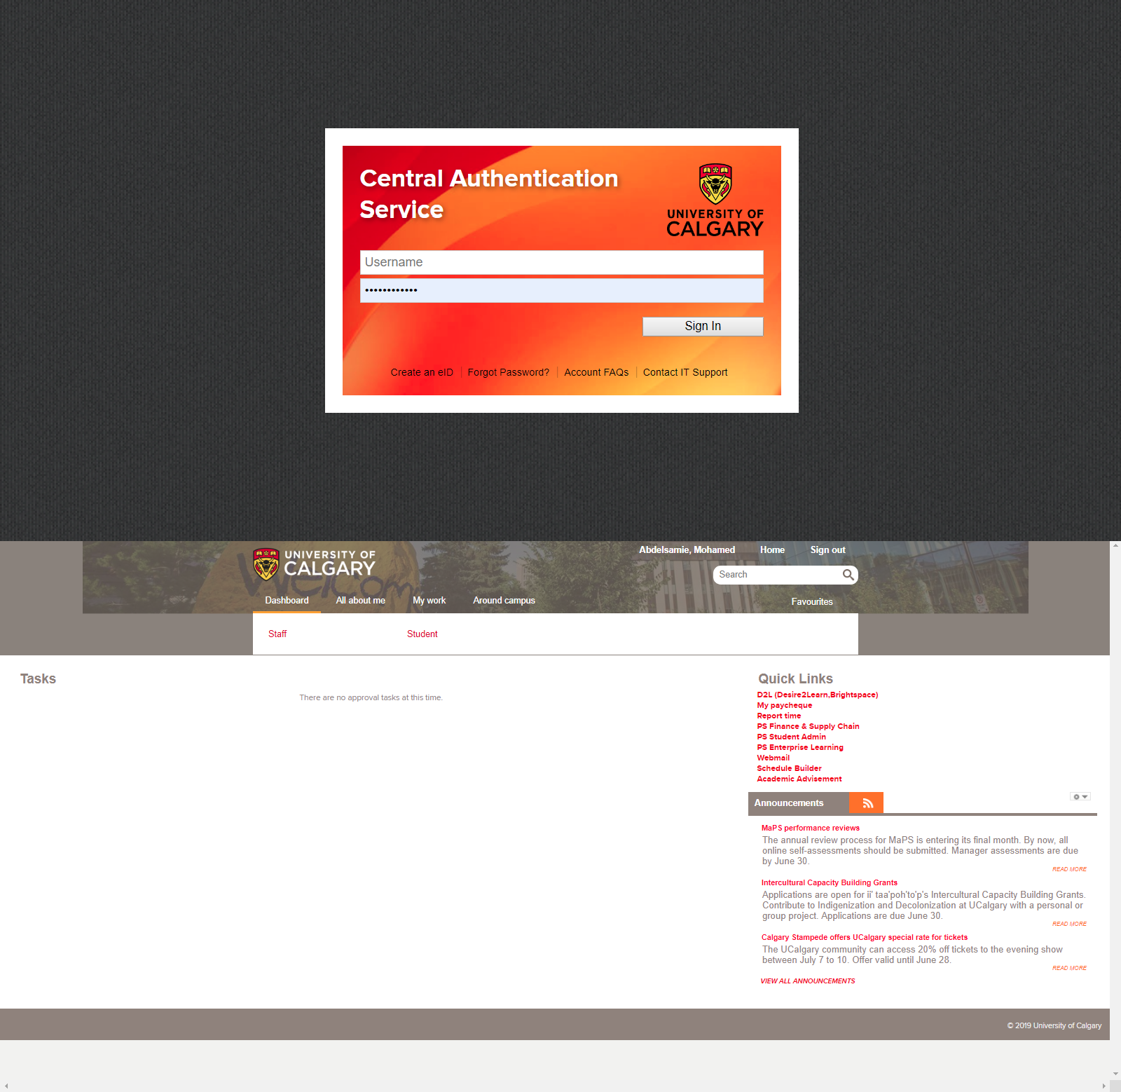

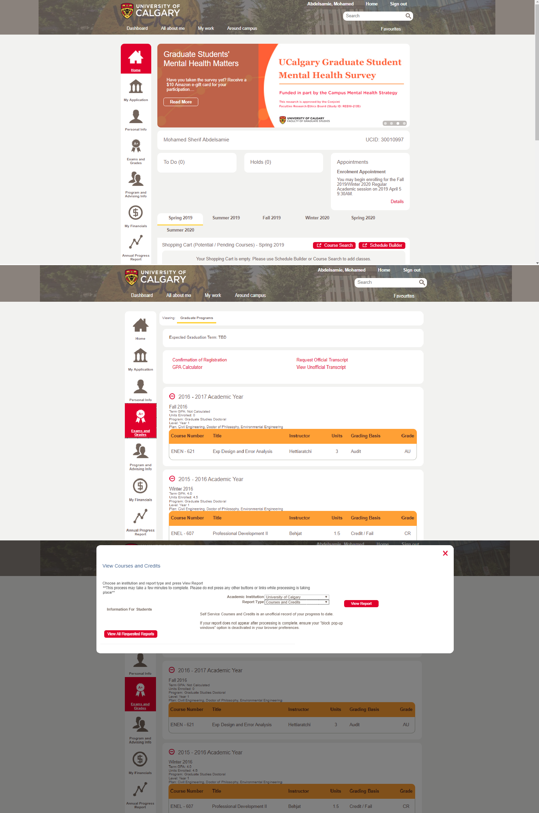

# 3

4

# 5 6